Q1. Read the ‘superstoreDataset.xlsx’ file and import the data into a dataframe. Please discover which column(s) has/have missing values. Display the records that they have a missing value. You should have 63 rows of such records.

Q2. Display the total sales based on State, Product Category and Product Sub-Category as follows.

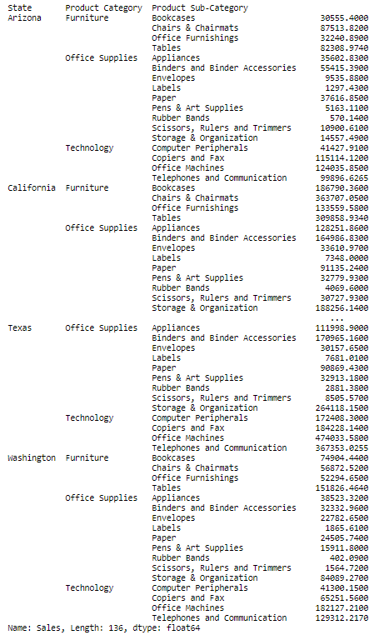

Q3. Show a sum of profit of each product sub-category sold in Texas and also a bar chart as follows.

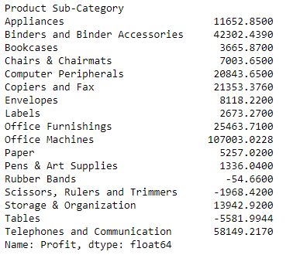

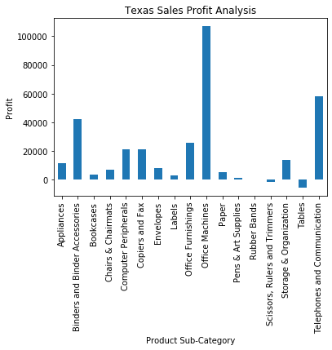

Q4. Display the data type of the values in the column of ‘Order Date’. If there is a need to change the column into a date, use an appropriate function to do it. If there is no need to do it, do not do it. Create a pivot table regrading the total sales of each state in each year. Then, draw a line chart to show the results.

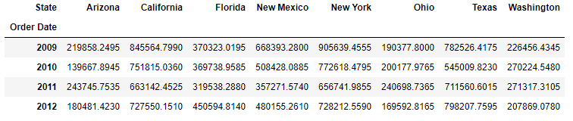

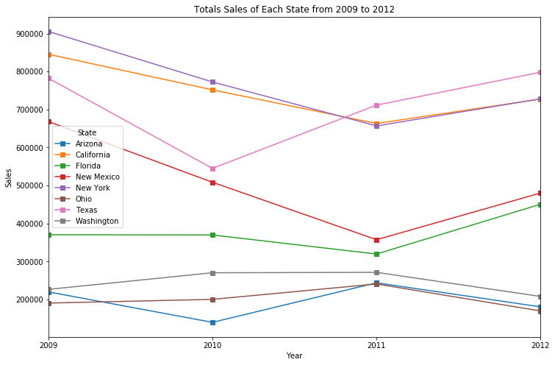

Q5. Create a histogram chart, a density chart and distplot chart based on the Appliances unit prices. Define appropriate titles, labels.

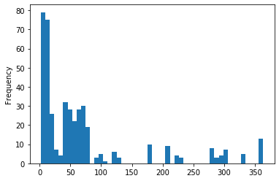

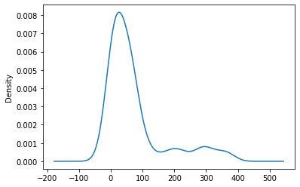

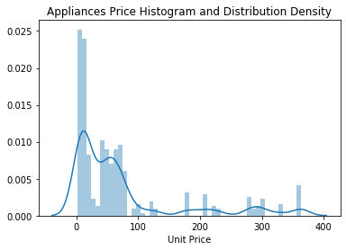

Q6. Create a stacked column chart based on the total sales of each product category in each state.

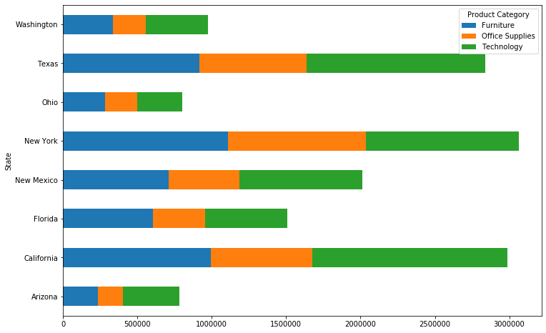

Q7. Display the top 10 customers who made largest sales in 2011.

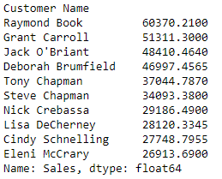

Q8. Display a heat map of the number of orders based on states and years. In which year and which state the most orders were placed?

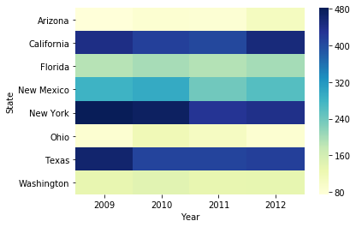

Q9. Please show the percentage of the amount of shipping cost by the amount of sales for the orders amount between 50 and 500 (inclusively)



Q10. Create a figure with two subplots in which a subplot shows a bar chart of the average discount rates by product categories and another subplot shows a bar chart of the average discount rates by customer segments.

